*1. Write a program in assembly language to perform subtraction of 8-bit data.*

*CODE:-*

org 100h

num1 db 45h

num2 db 12h

start:

mov al, num1

sub al, num2

mov bl, al

mov ah, al

and ah, 0F0h

shr ah, 4

add ah, 30h

cmp ah, 39h

jle print_first_digit

add ah, 7

print_first_digit:

mov dl, ah

mov ah, 02h

int 21h

mov ah, bl

and ah, 0Fh

add ah, 30h

cmp ah, 39h

jle print_second_digit

add ah, 7

print_second_digit:

mov dl, ah

mov ah, 02h

int 21h

mov ah, 4Ch

int 21h

*OUTPUT:-*

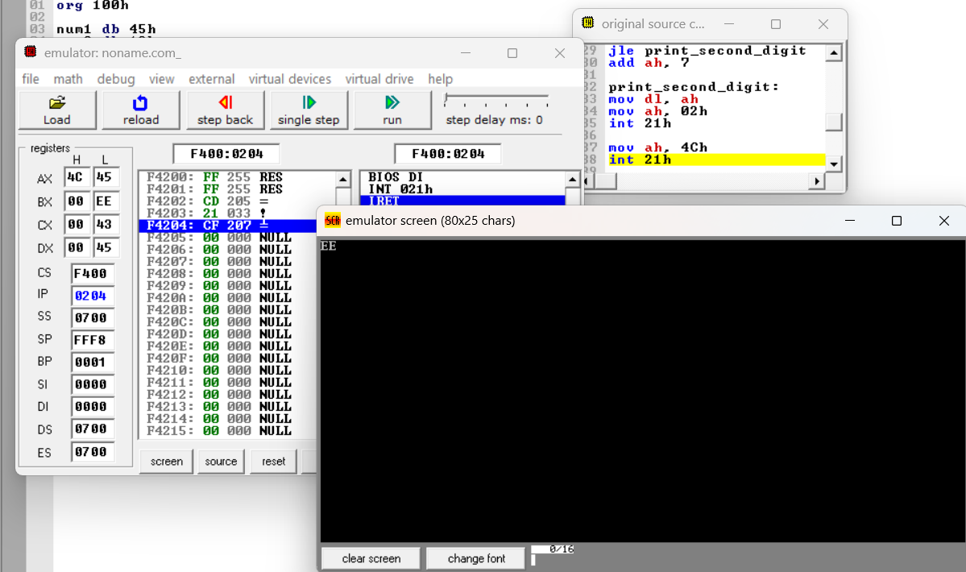

*2. Write an assembly language program to perform subtraction of 16-bit data.*

*CODE:-*

org 100h

num1 dw 1234h

num2 dw 0567h

result dw ?

start:

mov ax, num1

sub ax, num2

mov result, ax

mov bx, result

call print_number

mov ah, 4Ch

int 21h

print_number:

mov cx, 4

print_loop:

mov al, bl

shr al, 4

and al, 0Fh

add al, 30h

cmp al, 39h

jle print_digit

add al, 7

print_digit:

mov dl, al

mov ah, 02h

int 21h

shl bl, 4

loop print_loop

ret

*OUTPUT:-*

